**SYSTEM ARCHITECTURE**

BACK END

(.Net Core)

Database

(Ms SQL Server Db)

Elastic Search

PERSISTENCE

LAYER

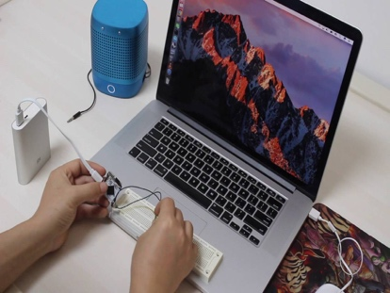

[This Photo](https://www.electronics-lab.com/4-coin-sized-linux-computer-wifi/) by Unknown Author is licensed under [CC BY-SA](https://creativecommons.org/licenses/by-sa/3.0/)

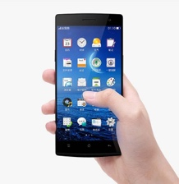

[This Photo](https://gadgetsin.com/oppo-find-7-android-phone-launched.htm) by Unknown Author is licensed under [CC BY-SA-NC](https://creativecommons.org/licenses/by-nc-sa/3.0/)

FRONT

END

(IONIC)